# Database Programming with SQL

**2-1: Working with Columns, Characters, and Rows**

In SQL, specific data attributes are represented by columns in a table, and you can choose to manipulate them using different commands, which apply multiple functions to columns. Row operations include selecting, filtering and manipulating sets of data records.

1. The manager of Global Fast Foods would like to send out coupons for the upcoming sale. He wants to send one coupon to each household. Create the SELECT statement that returns the customer last name and a mailing address.

* SELECT last_name, address FROM f_customers;

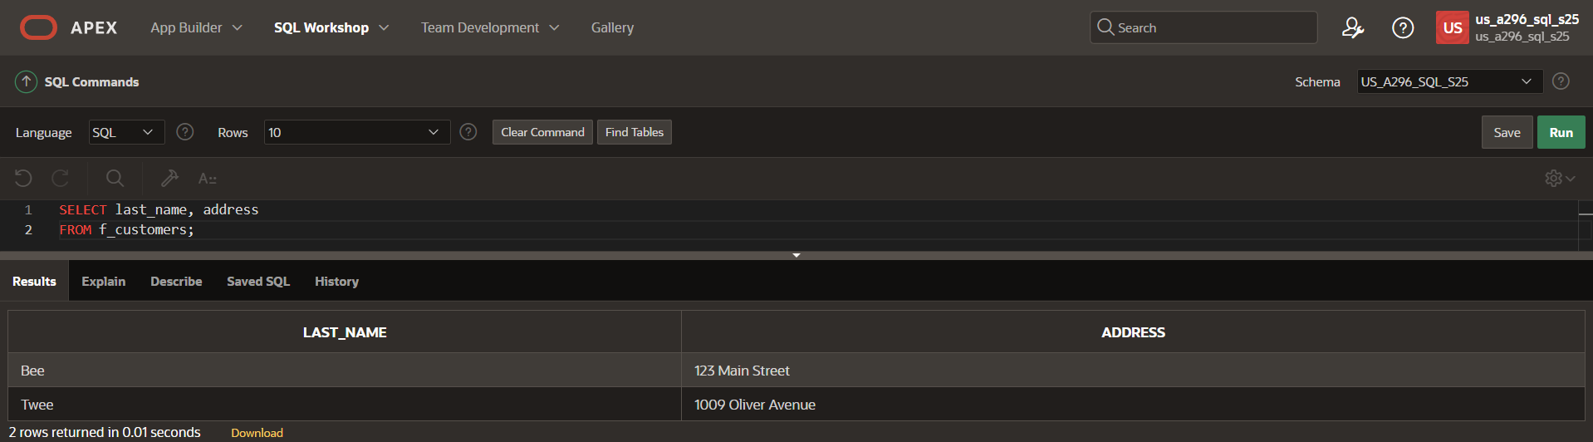

1. Each statement below has errors. Correct the errors and execute the query in Oracle Application Express.
2. SELECT first name FROM f_staffs;

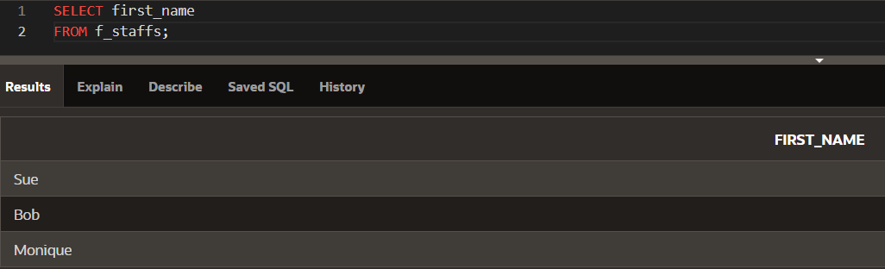

1. SELECT first_name |" " | last_name AS "DJs on Demand Clients" FROM d_clients;

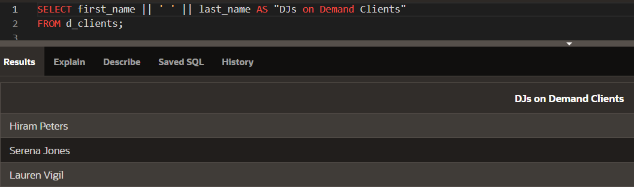

1. SELECT DISCTINCT f_order_lines FROM quantity;

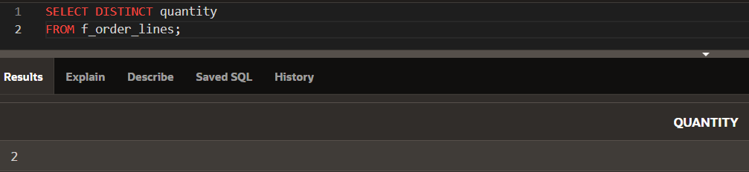

1. SELECT order number FROM f_orders;

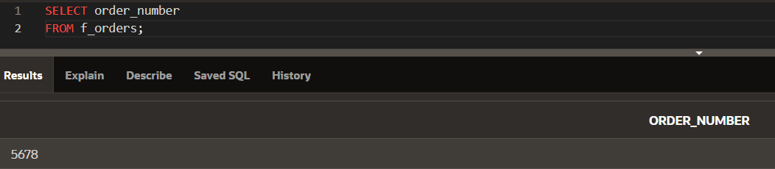

1. Sue, Bob, and Monique were the employees of the month. Using the f_staffs table, create a SELECT statement to display the results as shown in the Super Star chart.

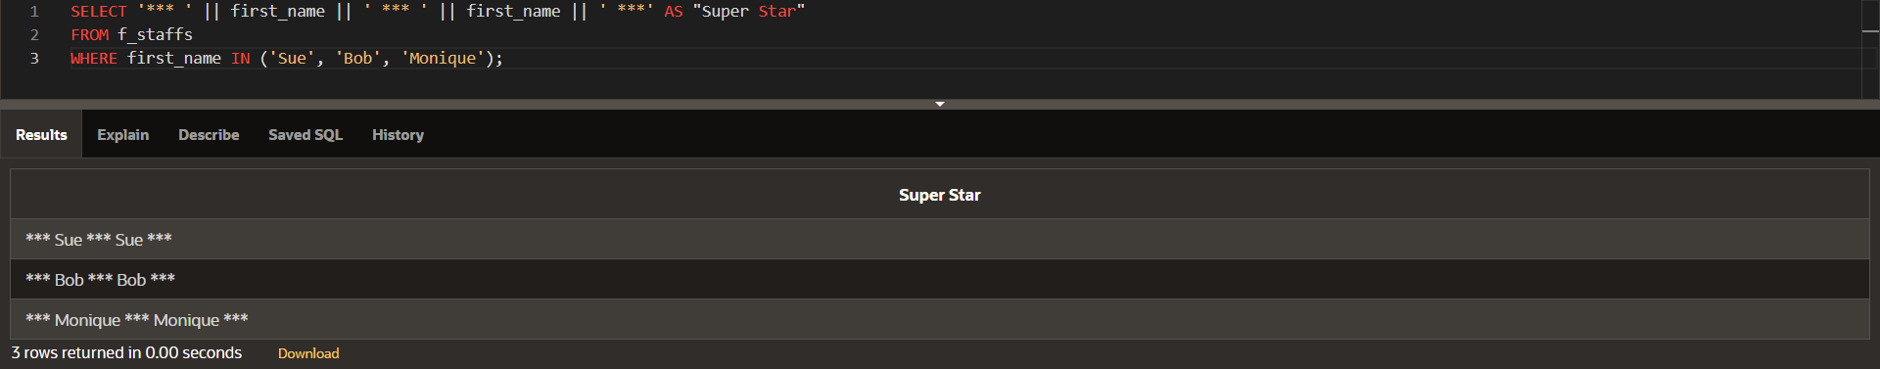

1. Which of the following is TRUE about the following query? SELECT first_name, DISTINCT birthdate FROM f_staffs;
2. Only two rows will be returned.
3. Four rows will be returned.
4. Only Fred 05-Jan-1988 and Lizzie 10-Nov-1987 will be returned.
5. **No rows will be returned.**
6. Global Fast Foods has decided to give all staff members a 5% raise. Prepare a report that presents the output as shown in the chart.

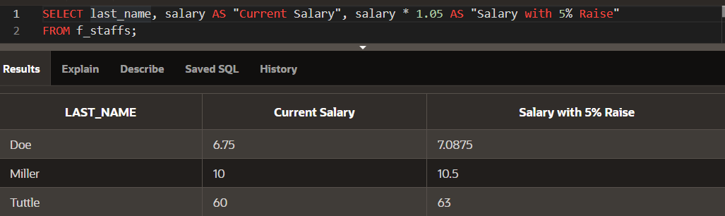

1. Create a query that will return the structure of the Oracle database EMPLOYEES table. Which columns are marked “nullable”? What does this mean?

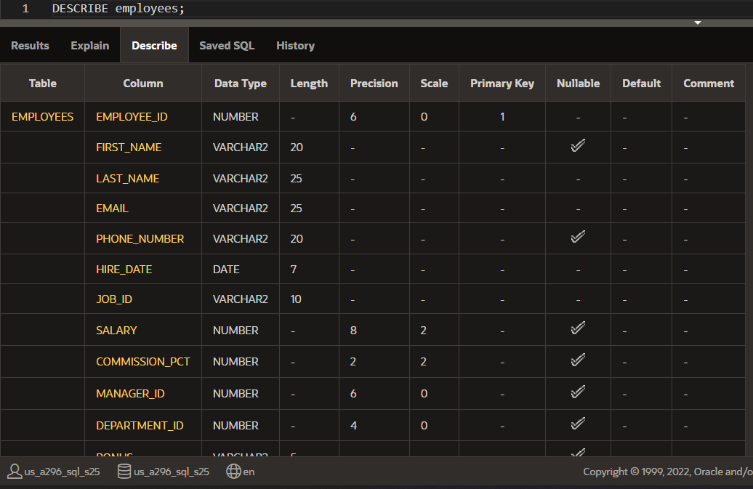

Nullable columns will be marked as YES. This means these columns can accept NULL values, indicating that the field is optional.

1. The owners of DJs on Demand would like a report of all items in their D_CDs table with the following column headings: Inventory Item, CD Title, Music Producer, and Year Purchased. Prepare this report.

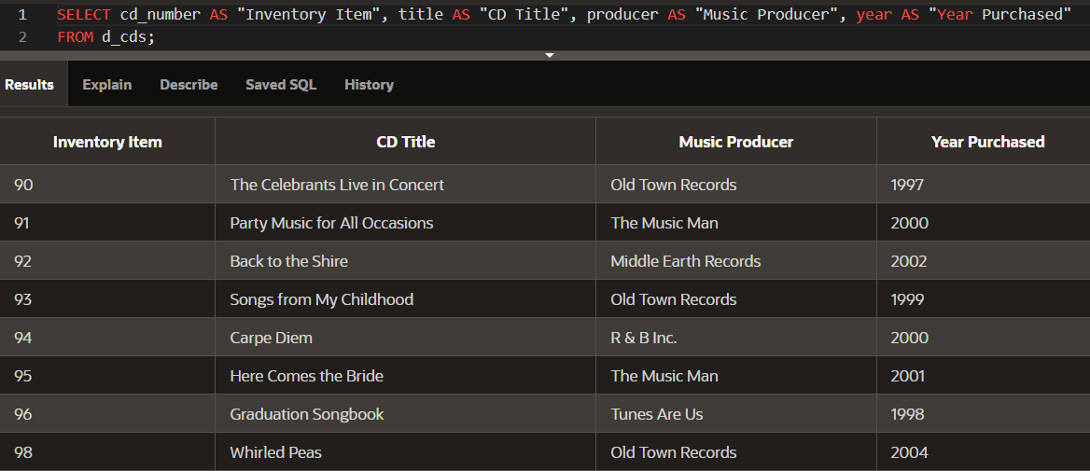

1. True/False -- The following SELECT statement executes successfully: SELECT last_name, job_id, salary AS Sal FROM employees;

**TRUE**

1. True/False -- The following SELECT statement executes successfully: SELECT * FROM job_grades

**TRUE**

1. There are four coding errors in this statement. Can you identify them? SELECT employee_id, last_name sal x 12 ANNUAL SALARY FROM employees;
2. Missing “,” between column selections.
3. “sal x 12” should be written as “salary * 12”
4. Missing “AS” for alias.
5. Incorrect alias name without double quotes.
6. In the arithmetic expression salary*12 - 400, which operation will be evaluated first?

In the expression salary*12 - 400, multiplication (*) will be evaluated before subtraction (-).

1. Which of the following can be used in the SELECT statement to return all columns of data in the Global Fast Foods f_staffs table?
2. Column names
3. *
4. DISTINCT id
5. Both a and b
6. Using SQL to choose the columns in a table uses which capability?
7. Selection
8. Projection
9. Partitioning
10. join
11. SELECT last_name AS "Employee". The column heading in the query result will appear as:
12. EMPLOYEE
13. employee
14. Employee
15. “Employee:
16. Which expression below will produce the largest value?
17. SELECT salary*6 + 100
18. SELECT salary* (6 + 100)
19. SELECT 6(salary+ 100)
20. SELECT salary+6*100
21. Which statement below will return a list of employees in the following format? Mr./Ms. Steven King is an employee of our company.
22. SELECT "Mr./Ms."||first_name||' '||last_name 'is an employee of our company.' AS "Employees" FROM employees;
23. SELECT 'Mr./Ms. 'first_name, last_name ||' '||'is an employee of our company.' FROM employees;
24. SELECT 'Mr./Ms. '||first_name||' '||last_name ||' '||'is an employee of our company.' AS "Employees"
25. SELECT Mr./Ms. ||first_name||' '||last_name ||' '||"is an employee of our company." AS "Employees" FROM employees
26. Which is true about SQL statements?
27. SQL statements are case-sensitive
28. SQL clauses should not be written on separate lines.
29. Keywords cannot be abbreviated or split across lines.
30. SQL keywords are typically entered in lowercase; all other words in uppercase.
31. Which queries will return three columns each with UPPERCASE column headings?
32. SELECT "Department_id", "Last_name", "First_name" FROM employees;
33. SELECT DEPARTMENT_ID, LAST_NAME, FIRST_NAME FROM employees;
34. SELECT department_id, last_name, first_name AS UPPER CASE FROM employees
35. SELECT department_id, last_name, first_name FROM employees;
36. Which statement below will likely fail?
37. SELCT * FROM employees; (Mis-spelled)
38. Select * FROM employees;
39. SELECT * FROM EMPLOYEES;
40. SelecT* FROM employees;

**2-2: Limit Rows Selected**

1. Using the Global Fast Foods database, retrieve the customer’s first name, last name, and address for the customer who uses ID 456.

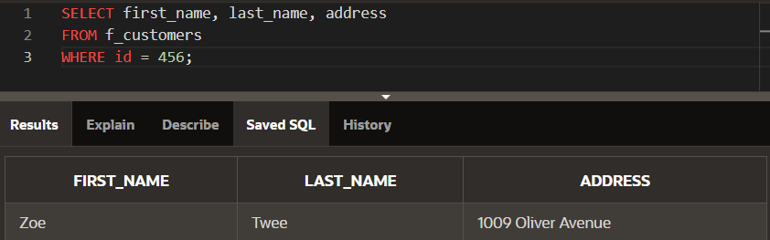

1. Create a SQL statement that produces the following output:

|  |
| --- |
| Oldest |
| The 1997 recording in our database is The Celebrants Live in Concert |

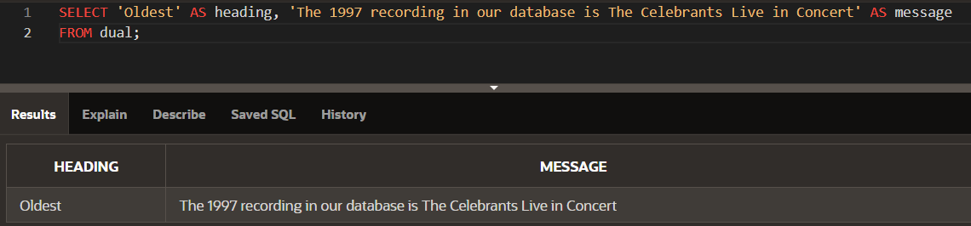

1. The following query was supposed to return the CD title “Carpe Diem" but no rows were returned. Correct the mistake in the statement and show the output.

SELECT produce, title

FROM d_cds

WHERE title = ‘carpe diem’

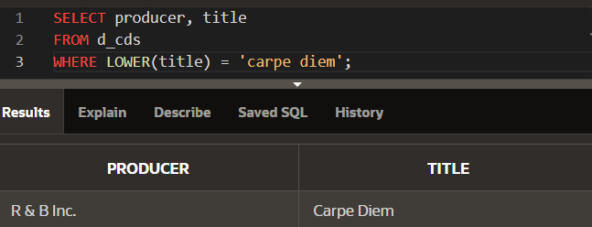

1. The manager of DJs on Demand would like a report of all the CD titles and years of CDs that were produced before 2000.

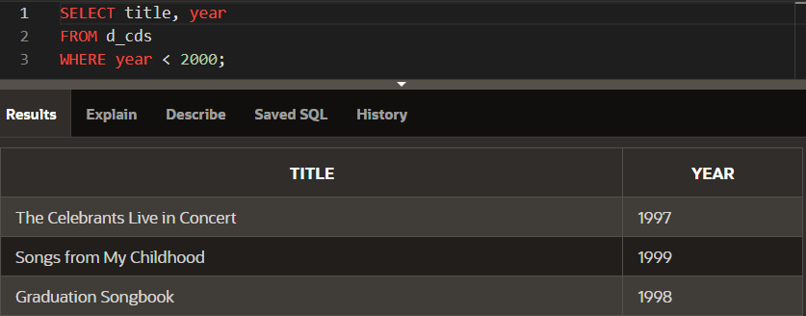

1. Which values will be selected in the following query? SELECT salary FROM employees WHERE salary < = 5000
2. **5000**
3. **0 – 4999**
4. 2500
5. 5

**For the next three questions, use the following table information:**

TABLE NAME: students

COLUMNS:

studentno NUMBER(6)

fname VARCHAR2(12)

lname VARCHAR(20)

sex CHAR(1)

major VARCHAR2(24)

1. Write a SQL statement that will display the student number (studentno), first name (fname), and last name (lname) for all students who are female (F) in the table named students.

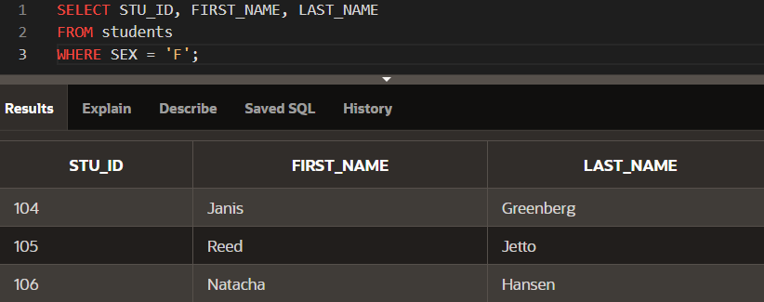

1. Write a SQL statement that will display the student number (studentno) of any student who has a PE major in the table named students. Title the studentno column Student Number.

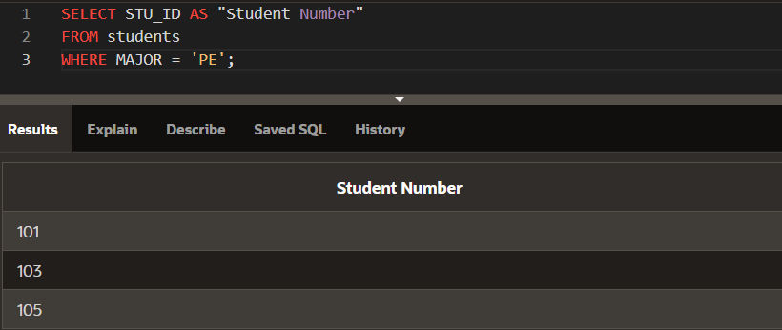

1. Write a SQL statement that lists all information about all male students in the table named students.

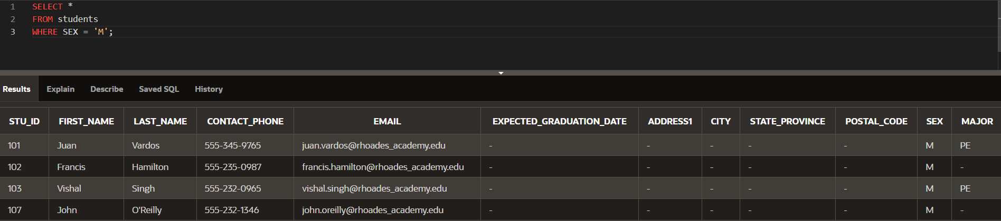

1. Write a SQL statement that will list the titles and years of all the DJs on Demand CDs that were not produced in 2000.

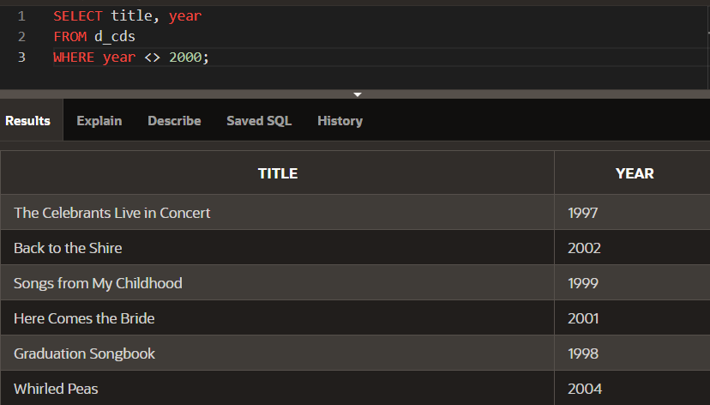

1. Write a SQL statement that lists the Global Fast Foods employees who were born before 1980.

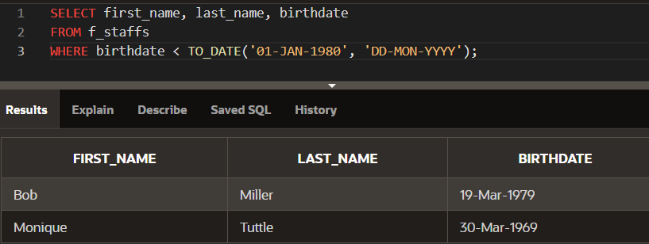

**2-3: Comparison Operators Practice Activities**

1. Display the first name, last name, and salary of all Global Fast Foods staff whose salary is between $5.00 and $10.00 per hour

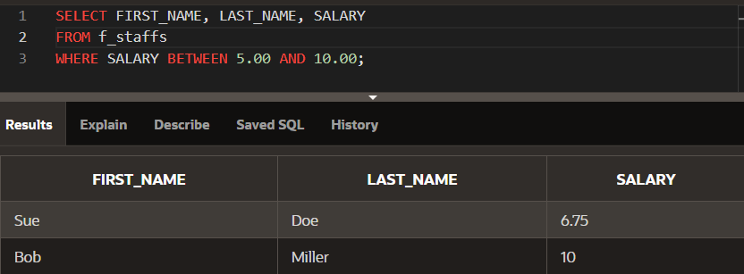

1. Display the location type and comments for all DJs on Demand venues that are Private Home.

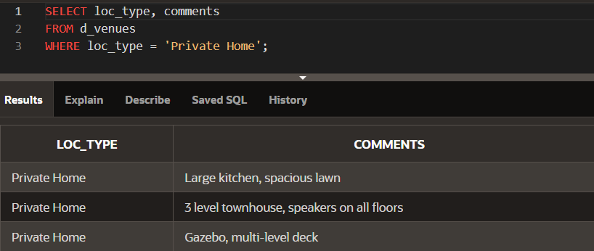

1. Using only the less than, equal, or greater than operators, rewrite the following query:

SELECT first_name, last_name FROM f_staffs WHERE salary BETWEEN 20.00 and 60.00;

**SELECT first_name, last_name**

**FROM f_staffs**

**WHERE salary >= 20.00 AND salary <= 60.00;**

1. Create a list of all the DJs on Demand CD titles that have “a” as the second letter in the title.

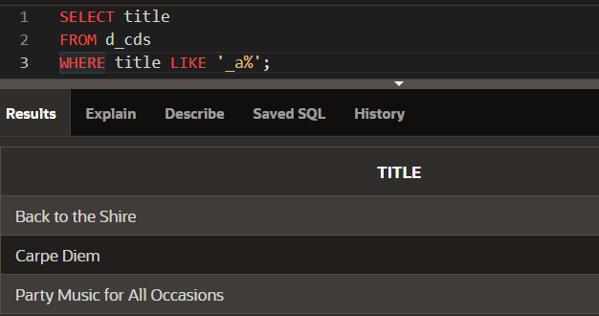

1. Who are the partners of DJs on Demand who do not get an authorized expense amount?

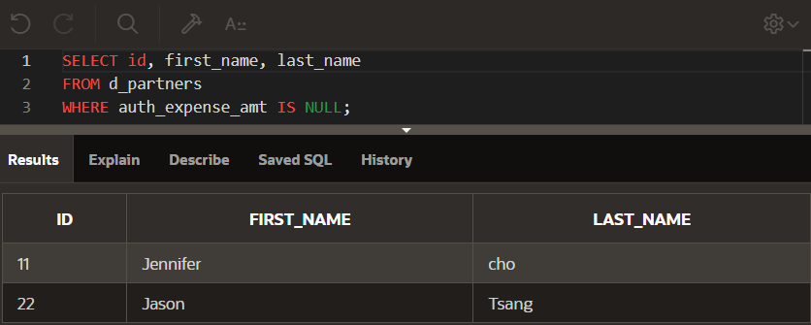

1. Select all the Oracle database employees whose last names end with “s”. Change the heading of the column to read Possible Candidates

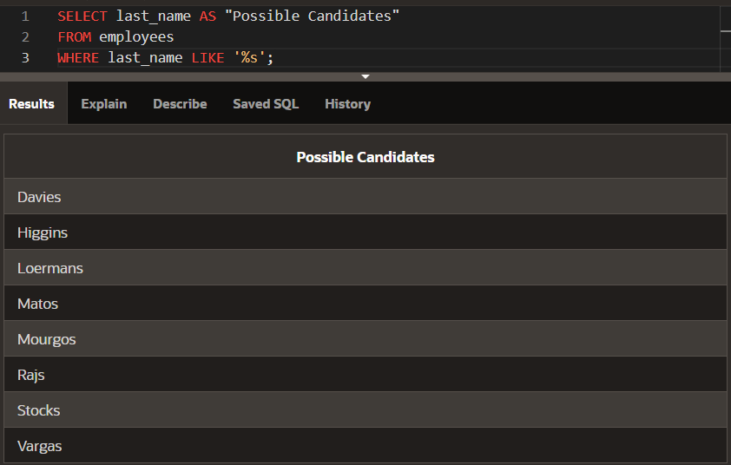

1. Which Statement(s) are valid?
2. WHERE quantity <> NULL;
3. WHERE quantity = NULL;
4. **WHERE quantity IS NULL;**
5. WHERE quantity != NULL;
6. 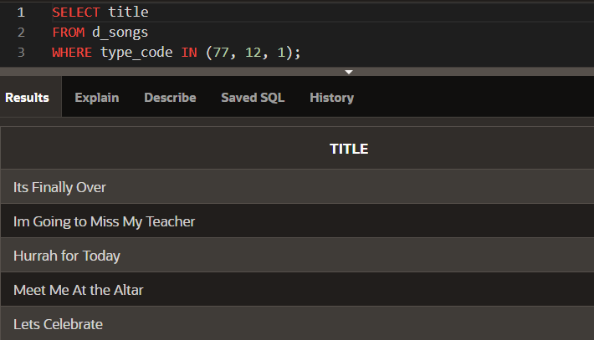Write a SQL statement that lists the songs in the DJs on Demand inventory that are type code 77, 12, or 1.